Dokuwiki-Server: Teil 8
Letztes Update 2020/12/06 01:00
WEB-Server
Für den Aufruf der installierten WEB-Dienste wird ein kleiner WEB-Server eingerichtet. Für die Installation des Dokuwiki-Servers wurde ein Apache WEB-Server installiert. Auf diesem werden nun einige HTML-Seiten eingerichtet, um Dienste, wie phpMyAdmin, NextCloud, die Grafik der CPU-Temperatur oder was sonst noch anliegt, zu starten.
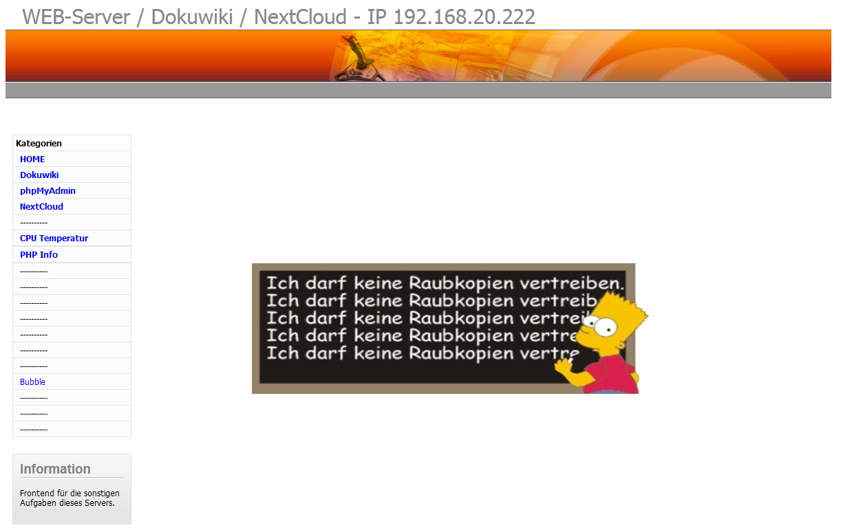
Die Struktur dieser Seite sieht wie folgt aus:
\html
|
+--- index.html
| |
| +--- main.html
| |
| +--- links.html
| |
| +--- oben.html
| |
| +--- ll.html
|
+--- style.css
|
+--- \gfx

<!DOCTYPE HTML PUBLIC "-//W3C//DTD HTML 4.01 Frameset//EN">
<html>
<head>
<title>Dokuwiki WEB-Server</title>
<link rel="shortcut icon" href="gfx/EDE.ico" type="image/vnd.microsoft.icon">
<style type="text/css">
<!--
.Stil2 {color: #DCF1FE}
-->
</style>
<meta name="robots" content="noindex,nofollow">
</head>
<frameset framespacing="0" border="true" frameborder="0" rows="220,*">
<frame name="oben" src="oben.html">
<frameset framespacing="0" border="true" frameborder="0" cols='20,180,40,*'>
<frame name="ll" src="ll.html">
<frame name="links" src="links.html">
<frame name="ll" src="ll.html">
<frame name="anzeige" src="main.html">
</frameset>
</frameset>
</html>

<!DOCTYPE HTML PUBLIC "-//W3C//DTD HTML 4.01 Frameset//EN">
<html><head>
<title>main</title>
</head>
<body>
<table border=0 cellpadding=0 cellspacing=0 width=80% height=80%>
<tr>
<td align=center><img height='190' width='579' src="gfx/raubkopie.jpg"></td>
</tr>
</table>
</body></html>

<html>
<!DOCTYPE html PUBLIC "-//W3C//DTD XHTML 1.0 Transitional//EN" "http://www.w3.org/TR/xhtml1/DTD/xhtml1-transitional.dtd">
<head>
<title>Dokupedia</title>
<meta http-equiv="Content-Type" content="text/html; charset=iso-8859-1">
<meta name="robots" content="index,nofollow">
<link rel="stylesheet" type="text/css" href="style.css">
</head>
<body>
<table width="100%" align="left" border="0" cellspacing="0" cellpadding="0">
<tr>
<!-- left panel-->
<td width="18%" align="left" valign="top">
<table width="100%" border="0" cellspacing="1" cellpadding="4" class="bg_grey">
<tr><td class="bold bg_white">Kategorien</td></tr>
<tr>
<td valign="top" class="bg_light_grey padding_left_10">
<a href="main.html" class="light_blue hover_red nodecoration" onmouseout="window.status=''" onmouseover="window.status='Pinout RPi'; return true;" target="anzeige">
<B>HOME</B></a>
</td>
</tr>
<tr>
<td valign="top" class="bg_light_grey padding_left_10">
<a href="http://192.168.20.222/dokuwiki/doku.php?id=start" class="light_blue hover_red nodecoration" onmouseout="window.status=''" onmouseover="window.status='Pinout RPi'; return true;" target="_NEW">
<B>Dokuwiki</B></a>
</td>
</tr>
<tr>
<td valign="top" class="bg_light_grey padding_left_10">
<a href="http://192.168.20.222/phpmyadmin/" class="light_blue hover_red nodecoration" onmouseout="window.status=''" onmouseover="window.status='Spiele'; return true;"target="_NEW">
<B>phpMyAdmin</B></a>
</td>
</tr>
<tr>
<td valign="top" class="bg_light_grey padding_left_10">
<a href="http://192.168.20.222/nextcloud/" class="light_blue hover_red nodecoration" onmouseout="window.status=''" onmouseover="window.status='Spiele'; return true;"target="_NEW">
<B>NextCloud</B></a>
</td>
</tr>
<tr>
<td valign="top" class="bg_light_grey padding_left_10">
<!a href="http://192.168.20.222/cpu_temperatur.png" class="light_blue hover_red nodecoration" onmouseout="window.status=''" onmouseover="window.status='Systemanwendungen'; return true;"target="_NEW">
----------</a>
</td>
</tr>
<tr>
<td valign="top" class="bg_light_grey padding_left_10">
<a href="http://192.168.20.222/cpu_temperatur.png" class="light_blue hover_red nodecoration" onmouseout="window.status=''" onmouseover="window.status='Spiele'; return true;"target="anzeige">
<B>CPU Temperatur</B></a>
</td>
</tr>
<tr>
<tr>
<td valign="top" class="bg_light_grey padding_left_10">
<a href="http://192.168.20.222/phpinfo.php" class="light_blue hover_red nodecoration" onmouseout="window.status=''" onmouseover="window.status='Spiele'; return true;"target="anzeige">
<B>PHP Info</B></a>
</td>
</tr>
<tr>
<tr>
<td valign="top" class="bg_light_grey padding_left_10">
<!a href="PinRPi.html" class="light_blue hover_red nodecoration" onmouseout="window.status=''" onmouseover="window.status='Pinout RPi'; return true;" target="anzeige">
----------</a>
</td>
</tr>
<tr>
<td valign="top" class="bg_light_grey padding_left_10">
<!a href="PinRPiPlus.html" class="light_blue hover_red nodecoration" onmouseout="window.status=''" onmouseover="window.status='Grafikanwendungen'; return true;"target="anzeige">
----------</a>
</td>
</tr>
<tr>
<td valign="top" class="bg_light_grey padding_left_10">
<!a href="HardReset.html" class="light_blue hover_red nodecoration" onmouseout="window.status=''" onmouseover="window.status='Sicherheitsrelevante Anwendungen'; return true;"target="anzeige">
----------</a>
</td>
</tr>
<tr>
<td valign="top" class="bg_light_grey padding_left_10">
<!a href="SoftReset.html" class="light_blue hover_red nodecoration" onmouseout="window.status=''" onmouseover="window.status='Internetanwendungen'; return true;"target="anzeige">
----------</a>
</td>
</tr>
<tr>
<td valign="top" class="bg_light_grey padding_left_10">
<!a href="av.html" class="light_blue hover_red nodecoration" onmouseout="window.status=''" onmouseover="window.status='A/V Anwendungen'; return true;"target="anzeige">
----------</a>
</td>
</tr>
<tr>
<td valign="top" class="bg_light_grey padding_left_10">
<!a href="sys.html" class="light_blue hover_red nodecoration" onmouseout="window.status=''" onmouseover="window.status='Systemanwendungen'; return true;"target="anzeige">
----------</a>
</td>
</tr>
<tr>
<td valign="top" class="bg_light_grey padding_left_10">
<!a href="tool.html" class="light_blue hover_red nodecoration" onmouseout="window.status=''" onmouseover="window.status='TOOLS'; return true;"target="anzeige">
----------</a>
</td>
</tr>
<tr>
<td valign="top" class="bg_light_grey padding_left_10">
<a href="bubbleshooter2.swf" class="light_blue hover_red nodecoration" onmouseout="window.status=''" onmouseover="window.status='Spiel'; return true;"target="_NEW">
Bubble</a>
</td>
</tr>
<tr>
<td valign="top" class="bg_light_grey padding_left_10">
<!a href="dev.html" class="light_blue hover_red nodecoration" onmouseout="window.status=''" onmouseover="window.status='Entwicklungssoftware'; return true;"target="anzeige">
----------</a>
</td>
</tr>
<tr>
<td valign="top" class="bg_light_grey padding_left_10">
<!a href="eb.html" class="light_blue hover_red nodecoration" onmouseout="window.status=''" onmouseover="window.status='eBooks zu verschiedenen Themen'; return true;"target="anzeige">
----------</a>
</td>
</tr>
<tr>
<td valign="top" class="bg_light_grey padding_left_10">
<!a href="gan.html" class="light_blue hover_red nodecoration" onmouseout="window.status=''" onmouseover="window.status='Spiele'; return true;"target="anzeige">
----------</a>
</td>
</tr>
</tr>
</table>
<br>
<table cellspacing="5" cellpadding="5" style="margin-top: 10px; margin-bottom:10px;border: 1px solid #dddee0; background: #f9f9f9 url('gfx/forsale_box_fade.gif') 0% 100% repeat-x;">
<tr>
<td align="left">
<div style="color:#808284; font-size:14pt; font-weight:bold;font-family:arial,sans-serif;">Information &nbsp;&nbsp;&nbsp;</div>
<div style="width:100%; border-bottom:1px solid #cccccc;height:1px"></div>
</td>
</tr>
<tr>
<td>
Frontend für die sonstigen Aufgaben dieses Servers.
<!a href="impress.html" class="light_blue hover_red nodecoration" onmouseout="window.status=''" onmouseover="window.status='null'; return true;"> <!/a>
<br>
<br>
</td>
</tr>
</table>
</td>
<td width="1%">&nbsp;</td>
<!-- main panel-->
</tr>
</table>
</html>

<!DOCTYPE HTML PUBLIC "-//W3C//DTD HTML 4.01 Frameset//EN">
<html>
<head>
<title>Dokuwiki</title>
<meta http-equiv="Content-Type" content="text/html; charset=iso-8859-1">
<meta name="robots" content="index,nofollow">
<link rel="stylesheet" type="text/css" href="style.css">
</head>
<body>
<style="background: #fbfbfb url(gfx/grey_fade.gif) repeat-x;">
<!center>
<br>
<div style="width:1200px;background:#fff;padding:10px;">
<div style="font-size: 30px;text-align:left;padding-left:2%; padding-bottom:2px; color:#888a8c;">WEB-Server / Dokuwiki / NextCloud - IP 192.168.20.222</div>
<table width="100%" border="0" cellspacing="0" cellpadding="0" style="border-top: 1px solid #666">
<tr>
<td height="75" valign="top" align="left">
<table width="100%" border="0" cellpadding="0" cellspacing="0" style="background-image: url('gfx/bk_header.gif');">
<tr>
<td width="95%" align="right" dir="ltr" nowrap><img src="gfx/header.jpg" width="282" height="75" alt=""><img src="gfx/header2.jpg" width="397" height="75" alt=""></td>
<td width="5%">&nbsp;</td>
</tr>
</table>
</td>
</tr>
</table>
<!-- nav bar: categories 2 click-->
<table width="100%" border="0" cellspacing="0" cellpadding="0" style="background-color: #999; border-top: 1px solid #fff; border-bottom: 1px solid #666;">
<tr>
<td height="22" class="center right">
</td>
</tr>
</table>
<!/center>
</body>
</html>

<html>
<!DOCTYPE html PUBLIC "-//W3C//DTD XHTML 1.0 Transitional//EN" "http://www.w3.org/TR/xhtml1/DTD/xhtml1-transitional.dtd">
<head>
<title>Dokupedia</title>
<meta http-equiv="Content-Type" content="text/html; charset=iso-8859-1">
<meta name="robots" content="index,nofollow">
</head>
</html>

style.css
ZIP-Container mit den auf der Webseite benötigten Grafiken

